Request for Proposal

**Consultant Database Provider**

May 2021

If any part of this document is missing, please contact:

Erin Gallagher

Procurement

Telephone: (617) 850-3596

EGallagher@acadian-asset.com

**ACADIAN ASSET MANAGEMENT CONFIDENTIAL INFORMATION**

Property of Acadian Asset Management LLC.

Confidentiality Statement

This Request for Proposal (RFP) has been prepared by Acadian Asset Management LLC (Acadian Asset Management LLC) and is being provided to you as an opportunity to bid in consideration of your agreement to treat it as confidential. The information contained in this proposal and any related discussions or documents produced by Acadian Asset Management LLC or its advisers are confidential and proprietary information of Acadian Asset Management LLC. Acadian Asset Management LLC is not conveying any ownership to any party by disclosing this information. By accepting this document, you agree that you will hold this information in strict confidence and will not allow any other person or entity to see it or use it and you will not use it in any way other than to prepare the requested proposal. Finally, you will return this document and all copies you have made of it, to Acadian Asset Management LLC should you decline to submit a proposal or upon request by Acadian Asset Management LLC. Acadian Asset Management LLC may disclose information provided by the Supplier to Acadian Asset Management LLC in connection with any proposal to consultants engaged by Acadian Asset Management LLC who are assisting with this Request for Proposal.

**TABLE OF CONTENTS**

1. Overview and Introduction to RFP………………………………….. 4

2. RFP Instructions and Review Process……………………………… 4

3. Supplier Information …………………………………………………. 6

4. Product Functionality…………………………………………………. 8

5. Account Management & Service Levels…………………………… 8

6. Commercials…………………………………………………………… 9

**1. Overview and Introduction to RFP**

This RFP consists of several sections. The **Overview and Introduction to RFP** and **RFP Instructions and Review Process** sections are intended to provide you with the information you require to complete your RFP response. Supplier is expected to provide complete responses, as per instructions noted, in **Section 2** of this RFP.

**1.1. Acadian Asset Management LLC Overview**

Acadian Asset Management LLC is a U.S. Securities and Exchange Commission-registered investment adviser and Boston-headquartered investment management firm that, along with its wholly-owned Singapore, Australia, and UK affiliates, specializes in systematic, active global and regional equity strategies.  As of March 31, 2021 the combined entities, which includes 370 employees, invested more than $111.5 billion on behalf of pension funds, endowments, foundations, governments, and other institutions globally.

Please review the Acadian Asset Management LLC website at <http://www.Acadian-Asset.com> for more information.

**1.2. Introduction to RFP**

Acadian Asset Management LLC’s (“Acadian”) is seeking proposal submissions from software/services application providers (Suppliers) to provide **Investment Consultant Database Services for our marketing efforts.**

The term “Supplier” as used in this RFP shall mean any person or supplier submitting a response to this RFP. This RFP describes the RFP event process and timeline, the business challenge we are seeking to solve and the qualitative content/questions which will help us understand your capabilities.

**2. RFP Instructions and Review Process**

**2.1.** Timeline

Supplier shall submit its RFP via e-mail within the timeframes indicated below. **Proposals will not be accepted via alternate means**. All dates are subject to change at Acadian Asset Management LLC’s sole discretion.

| **Activity** | **Deadline** |
| --- | --- |
| RFP Launch | 12 PM EDT, MONDAY, MAY 10, 2021 |
| Submission of Intent to Submit | 12 PM EDT, TUESDAY, MAY 11, 2021 |
| RFP Questions Submitted | 12 PM EDT, FRIDAY, MAY 14, 2021 |
| RFP Questions Answered | 5 PM EDT, TUESDAY, MAY 18, 2021 |
| RFP Responses Due | 12 PM EDT TUESDAY, June 1, 2021 |

**2.2. Communication and General Instructions**

To foster a fair and equitable review process, Acadian Asset Management LLC has designated **Erin Gallagher** ([egallagher@acadian-asset.com](mailto:egallagher@acadian-asset.com)) as the single point of contact. Erin is the only person authorized to respond to questions relating to this initiative on Acadian Asset Management LLC’s behalf. Erin will seek guidance from the internal stakeholders for answers to specific questions about the deliverables and provide the answers to Suppliers.

Please acknowledge your receipt of this RFP and intent to bid via e-mail to Erin ([EGallagher@acadian-asset.com](mailto:EGallagher@acadian-asset.com)) by **date/time noted in section 2.1.**

**2.3 Submission of Questions**

All questions related to this RFP must be directed to Erin ([EGallagher@acadian-asset.com](mailto:EGallagher@acadian-asset.com)) and submitted via e-mail no later than the **date/time noted in section 2.1.** To improve the quality of responses, Acadian Asset Management LLC may restate questions to make them anonymous and reserves the right to share all questions and answers with all Suppliers. Please reference the specific section/question number for each question you have, if applicable.

**2.4 RFP Submissions**

Please submit responses no later than **the date noted in section 2.1** via e-mail to Erin at [EGallagher@Acadian-Asset.com](mailto:EGallagher@Acadian-Asset.com). Responses must be submitted according to the instructions outlined in this RFP. Provide complete and detailed, but succinct answers. If a question is not applicable, please indicate so and explain the reason. Do not leave a question blank without notation. Omissions or misrepresentations of any information may result in disqualification from the selection process to participate in any next steps. Answer all questions only as they pertain to the scope of this RFP.

Your proposal should consist of four (4) files: 1) **Qualitative** – Sections 3, 4 and 5 of this RFP in Word/pdf format, **2) Pricing** - an Excel file completed as indicated in Section 6, **3)** **Executive Summary** – a ONE page Word/pdf file 4) **Master Services Agreement Template** – Word version of your Services Agreement as indicated in Section 6.

**2.5 Presentations**

A subset of participating Suppliers may be invited to provide Acadian Asset Management LLC with a presentation of their value offering. We will communicate a decision on which suppliers are invited to present as well as the date and time of the presentations by **mid June.**

Upon analysis of the RFP responses, we may want to meet the team that will be assigned to supporting our account in the event your firm is awarded the contract. This should include the lead contact who will be responsible for the implementation and any other individuals who will perform substantial services to our account.

**2.6 Participation Costs**

Any and all costs associated with responding to this Request for Information will be borne entirely by the Supplier.

**2.7 Rights of Acadian Asset Management LLC**

Acadian Asset Management LLC reserves and may exercise one or more of the following rights and options regarding this RFP:

* To accept or reject any and all responses to this RFP, or any portion thereof for any reason.
* To seek additional information from one or more qualified Suppliers.
* To cancel or withdraw this RFP at its sole discretion, without the substitution of another RFP, or to alter the terms and conditions and evaluation criteria of this RFP.
* Withhold the name of the selected supplier from other bidders.
* Withhold information pertaining to the final selection process.
* RFP content will be valid for 180 days from the RFP due date and may be extended beyond that time by mutual agreement of the parties.

Neither the receipt of any response nor failure to reject any response shall impose any legal obligation upon Acadian Asset Management LLC.

**2.8 RFP Evaluation Process**

This project is sponsored by a cross functional team who will evaluate the proposals and select potential qualifying Suppliers. Acadian’s Procurement department is administering this RFP on behalf of the cross functional team. Responses that meet the RFP instructions will be given a thorough and objective review. Late responses, those that do not comply with the instructions, or those that take exception to mandatory requirements may be disqualified.

Please refrain from making any inquiries about the evaluation of your proposal. Erin Gallagher will contact Supplier with updates on the status of its proposal and next steps. Following the analysis of the RFP responses, Supplier(s) will be contacted and informed of any next steps.

**3. Supplier Information**

**3.1 Supplier Profile**

Please provide information that will enable us to better understand your company:

1. Company description: including ownership, number of years in business, strategic direction, mission, history, acknowledgements and/or awards

**APX Stream is the largest independent global manager and distributor of investment data to the investment databases (e.g.: eVestment, PSN, Morningstar, Mercer, etc.).**

**APX Stream’s independence ensures that no conflicts of interest interfere with its core mission: to enhance the asset manager’s significance in the investment management industry through the effective deployment of market-leading data management and distribution tools, consulting, and services.**

**APX Stream Inc.’s core product is the DataDrive, a proprietary SQL database that provides the asset manager with seamless assembly, warehousing, reconciliation (verification), and distribution of investment data to more than 50 global databases and all programable questionnaires. The DataDrive is a “composite” of every industry database, enabling automated and reliable data distribution to the industry databases and marketing collateral, such as factsheets and retention DDQs.**

**APX Stream is a privately owned, minority-staffed business enterprise specializing in the financial technology (FinTech) space. All management and staff participate in the firm’s profit-sharing program.**

**Unlike other data distribution firms that are owned by large conglomerates, APX Stream focuses exclusively on investment data management and distribution. APX Stream’s sole purpose is to assist asset managers in leveraging the qualitative and quantitative data generated by their operations to grow AUM and retain existing clients.**

**Investment data management and marketing distribution is complex and highly specialized work that requires the focus of a team of experts in investment data itself, as well as marketing, sales, and technology.**

**Founded in March of 2010 as Portfolio Analytics, the company changed its name in 2014 to Jackson Analytics, and again in 2020 to APX Stream.**

**Submitted by one of APX Stream’s private-label partners, the DataDrive was awarded Barron’s “Disruptor of the Year” award for 2020 (https://www.mminst.org/mmi-news/mmibarrons-industry-awards-winners-announced). Additionally, APX Stream maintains a robust thought leadership position in the industry (apxstream.com/insights), as well as a consistent presence in the financial press. Most recently, APX Stream’s article on investment data compliance was published in the Investments and Wealth Institute’s** ® **bi-monthly magazine, Investments & Wealth Monitor. APX Stream is also frequently quoted in leading publications, such as FundFire and Emerging Manager Monthly.**

1. Describe your overall business offerings and how the consultant database function fits in.

**APX Stream’s singular focus is to assist asset managers to leverage their investment data to grow AUM and retain clients. Each of APX Stream’s product offerings is designed to address a specific strategy in that overall mission.**

**The investment industry databases have become the most valuable distribution point for asset manager marketing efforts, as databases are the first step in the due diligence process for investors and intermediaries of every size and type.**

**The APX Stream DataDrive is connected to more than 50 investment databases across the globe, with a lineup that changes every quarter due to factors such as industry consolidation and/or globalization. The DataDrive has established connectivity to raw data sources with additional connections being established every quarter.**

**APX Stream’s experience coding the DataDrive directly to the leading industry databases greatly informed our latest product development: automating the population of quarterly retention due diligence questionnaires.**

**APX Stream’s database strategy consulting services are deeply influenced by more than 30 years of broad industry experience, which will lend significant credibility to our work on behalf of Acadian’s database selection, data positioning, and topline marketing strategy.**

1. Public or private entity (if public, please provide ticker symbol and exchanges traded on)

**APX Stream is a privately-held firm.**

1. Is your company a MWDBE certified? Do you have a policy on diversity? If so, please include.

**APX Stream is not MWDBE-certified, but it is a minority-owned and minority-staffed firm.**

1. Most recent set of audited financial statements

**APX Stream is a privately-owned, profitable, and with confidential internal financial reports that are audited quarterly.**

1. Do any customers account for more than 25% or more of your revenue?

**No client accounts for more than 25% APX Stream’s revenues.**

1. Key partner/alliance relationships

**APX Stream has several Private Labeled Partnerships (PLP) with existing FinTech service providers. In these arrangements (each one unique), APX Stream builds and maintains a dedicated DataDrive which these Partners then utilize on behalf of their clients.**

**Additionally, APX Stream maintains close technical partnerships with each of the major industry databases for enhanced connectivity and reliable data flow.**

**Currently, APX Stream is expanding into Asia and Europe through key service providers in these markets.**

1. Description of selection criteria for contractor or co-implementation partners

**APX Stream has not employed contractors or co-implementation partners for the past 12 months. However, when APX Stream has done so in the past, strict criteria for all outsourced and/or contracted services are met. All contractors and/or vendors must go through a rigorous due diligence process to satisfy all questions and concerns pertaining to security and reliability. APX Stream’s process identifies and eliminates conflicts of interest and potential regulatory issues through extensive vetting and due diligence.**

**APX Stream’s focus is seamless connectivity between all of Acadian’s “data-in” sources with the relevant “data-out” portals and publications.**

1. Please describe your position on ESG and your related practices

**APX Stream is a minority-owned and accredited firm. We are an equal opportunity employer and over 60% of the firm staff are of minority ethnicities.**

**Insofar as APX Stream technology is concerned, Acadian’s DataDrive will capture and APX Stream will publish every ESG and Diversity/Inclusion data field across all databases and automated questionnaires. APX Stream is currently planning the first article on ESG data marketing and is in the process of editing for publication.**

**APX Stream is dedicated to reducing waste by implementing paper-less workspace practices. All documents, forms, and correspondence are maintained and backed up to a secure based system. All hard copies are disposed of according to sustainability and privacy best practices.**

**As the databases and questionnaires expand and become more prominent with regard to ESG, APX Stream’s datasets will expand likewise, capturing all the relevant data fields in this growing area of data marketing.**

1. Work force distribution by country, city, state, etc.

**All APX Stream staff members are based in the United States (Arizona, Illinois, and Texas), and are full time W-2 status.**

1. Total number of employees: include number of project managers, implementation specialists, development engineers, % full time versus contracted, etc.

**APX Stream employs 15 staff members, including:**

* + **5 development engineers**
  + **4 onboarding and implementation specialists / Senior Analyst**
  + **4 project managers / Senior Analysts**
  + **1 Full-time Senior Analyst**
  + **1 Full-time Junior Analyst**
  + **100% US-based and full-time**

1. Average number of years of industry related experience for leadership team

**30 Years Average - Accredited**

**3.2 Contact**

Please provide the following information for the person who will serve as your firm’s primary contact to Acadian Asset Management LLC during this RFP Process:

**Name: Richard W. Jackson CIMA®**

**Title: CEO**

**Address: 32880 IH-10 West, Suite 103, Boerne, Texas 78006**

**Phone: 888-411-1441**

**E-mail: Rjackson@apxstream.com**

**3.3 Risk and Controls**

3.3.1 Does your organization have an Enterprise Risk Management function? Please provide the mandate of the group and the reporting structure.

**It is the function of the Executive Team (CEO, CMO, COO, CTO) to assess, manage, and mitigate enterprise risk. Risk management sessions are held quarterly to evaluate cyber security, disaster recovery, and business continuity in the event of an emergency.**

3.3.2 What control activities and monitoring tools are in place within your organization to ensure compliance with changes in external requirements, such as ensuring regulatory and legal rules are incorporated in a timely manner? Are your data centers under local compliance requirements? If so, which ones?

**APX Stream is a member of Investments and Wealth Association (IWA) and Richard Jackson, CEO and Head of Research, is Accredited by IWA as a Certified Investment Management Analyst (CIMA®). Both IWA and the CIMA accreditation maintain rigorous codes of ethics.**

**APX Stream maintains alliances with several regulatory and independent compliance firms which assist in the writing and monitoring of regulatory issues surrounding the database and data marketing by asset managers.**

**Additionally, APX Stream’s comprehensive database research (see Exhibit 1) is updated, published, and reviewed with every client on a quarterly basis. APX Stream database research includes an assessment of database subscriber/user types, and clearly details adherence to the accredited investor and professional intermediaries.**

**APX Stream authored the first published article regarding investment data compliance and the SEC and FINRA regulations rolled out in Q1 2021. Additionally, APX Stream has conducted and participated in webinars focused on how emerging regulations now govern data marketing, alongside panels of industry experts and leaders in compliance.**

3.3.3 To the extent that any of your service providers outsource and / or subcontract their services as related to the initiative, please specify the nature of the services performed, vendor and location of where the services are performed. Please describe your oversight over these services.

**APX Stream relies solely on an in-house, full-time US-based Data Analyst and software development teams.**

3.3.4 Providers may be required to confirm compliance with our corporate policies on such items as IT Security and Code of Conduct. Describe your willingness to comply with the requirement.

**APX Stream works within the unique constraints of each asset manager’s sales, marketing, and compliance staff, and fully adheres to all corporate policies regarding regulatory and branding requirements. APX Stream writes, maintains, and reviews on a quarterly basis a data policy manual for every client, offering unfettered access to this manual via the manager’s portal in the DataDrive.  
  
APX Stream regularly (quarterly, semi-annually, annually) completes client-mandated security due diligence questionnaires.**

**When APX Stream has received and reviewed Acadian’s corporate policies on IT Security and its Code of Conduct, APX Stream will willingly comply with all requirements.**

3.3.5 Please describe your external audit environment. Include and identify all external auditors, regulators, government supervisory agencies and related exams. Do external auditors regularly perform the following services and if so, how frequently: (1) financial audit; (2) issuance of internal control reports; and (3) Technology/Computer Controls (e.g. Operations, Security, Change control process, SOC 2, etc.)?

**(1).** **APX Stream’s financials are independently audited monthly; (2). APX Stream, through its operational staff, audits all data distribution across the entire process of data assembly, management, and distribution; (3). APX Stream and its technology team audits all hardware and software applications on an ongoing basis.**

3.3.6 Describe your internal audit function. How large is the staff? Describe frequency and scope of audits. What is the reporting line of internal audit in your organization?

**APX Stream’s Chief Operating Officer is responsible for all internal and external audits of data. All reconciliation of client data is completed within 72 hours of distribution. Further reconciliation continues to occur over each quarter.**

3.3.7 How does your company ensure that employees have adequate knowledge and experience to fulfill their responsibilities? Describe your training programs. How do you train contract and temporary employees? If applicable to the services being provided, please include a description of your information security training and awareness programs. How do you ensure that there is a division of roles and responsibilities (segregation of duties) that reasonably prevents a single individual from subverting a critical process?

**APX Stream does not employ temporary employees. APX Stream assigns a Senior Analyst to each Junior Analyst to mentor and monitor their ongoing training. Training is considered a long-term, collaborative, ongoing business imperative.**

**Staff meetings occur every morning and all tasks are managed via a team-based approach. Daily tasks are assigned every morning and afternoon by the Chief Operating Officer.**

**The Senior and Junior Analyst training process covers five distinct areas:**

**Data center operations**

**Data processing and analysis**

**Solutions development**

**Communications**

**Client Services**

3.3.8 Describe your Disaster Recovery and Business Continuity plan. Include how often tests are performed, if an independent third party auditor has reviewed for best practices, who is responsible for the planning and if you review planning for your third party vendors.

**APX Stream has a detailed, ongoing recovery and continuity plan, not only for its own operations, but for its manager clients, as well. Though strictly managed day-to-day as a non-remote workplace, APX Stream is prepared to continue operations virtually in the event the office is inaccessible or inoperable. All data and servers are backed up daily through redundant systems. Testing occurs monthly.**

**4. Product Functionality / Capabilities**

Please include all items listed below in your response to this RFP.

4.1 Please provide a list of the current database platforms you work with.

**The investment database lineup is ever-evolving as new databases are added, merged, or subtracted every year. APX Stream has conducted significant, in-depth research into the subscribers and contributors in each of the current databases listed below. APX Stream’s database research is a unique differentiator in the database consulting services offered to Acadian.**

**APX Stream has established connectivity and analyst fluency with each database. Interestingly, APX Stream often identifies poorly-designed databases asset managers are required to populate. As a result, APX Stream has seen a marked increase in the number of databases requesting an outsourced, APX Stream-built “data-in” portal, which APX Stream provides. Our current database list includes:**

* **Aksia**
* **Albourne Moatspace**
* **Allocator**
* **Alpha Portfolio Advisors**
* **AsiaHedge (HFM Global)**
* **BarclayHedge**
* **Bloomberg**
* **Broadridge**
* **Callan Assoc.**
* **Cambridge Assoc.**
* **Camradata**
* **Cap Trust**
* **Cliffwater**
* **Crewcial Partners**
* **Concord Advisory Group**
* **Demarche Assoc.**
* **Diligence Vault**
* **Envestnet**
* **Ellwood**
* **EurekaHedge**
* **EUROHedge**
* **eVestment Alliance**
* **eVestment Alternative HFN**
* **FEG**
* **FINTROZ**
* **Global Manager Research**
* **Hedge Fund Intelligence**
* **Hedgefund Research**
* **Insurance Asset Outsourcing Exchange**
* **InsurerCIO**
* **Investment Metrics**
* **LCG Assoc.**
* **Meketa Group**
* **Mercer**
* **MMR**
* **Monticello Advisors**
* **Morgan Stanley/Graystone**
* **Morningstar**
* **Morningstar HF**
* **NEPC**
* **Nomura**
* **Preqin Hedge Fund Analyst**
* **Prime Buchholz**
* **PSN Informa**
* **Refinitiv/Lipper**
* **Rock Creek Group**
* **Russell**
* **RVK**
* **Segal Marco Advisors**
* **Townsend**
* **Willis Towers Watson**
* **Wilshire**
* **Xponance**

4.2 How do you engage with contacts at your current database platforms?

**APX Stream has longstanding, ongoing relationships with every database, at both the technical and management level. In its normal course of business, APX Stream is in contact with each database via telephone, email, and GoTo/Zoom/Teams meetings, at least quarterly.**

**Because APX Stream has established close working relationships with the databases, the firm is informed of any platform changes or any additions, well in advance of the public roll out/implementation (though APX Stream does not rely solely on database disclosure of changes). APX Stream’s Senior Analyst Team conducts thorough, external audits every quarter using the firm’s thorough 3-step reconciliation system.**

4.3 What is the process to have your firm engage with a new database platform?

**APX Stream is routinely asked by manager clients to research and publish to new databases. APX Stream initiates a full due diligence and research process upon each request, and its Tech and Analyst Teams connect for automation and training.**

**A core component of APX Stream’s consulting work is to advise clients on how their database footprint can evolve, including databases to which the asset manager can and should publish.**

4.4 Please describe the onboarding process. Please comment on the timing and effort that is expected along with a proposed implementation project plan.

**APX Stream strives to make the onboarding process as seamless as possible. APX Stream believes its primary onboarding obligation is to lift from Acadian as much of the responsibility for the process as is possible, from start to finish. “Lift” is the theme in everything APX Streams does along every step in the onboarding process, from initial data migration into the DataDrive to establishing connectivity with every field in the appropriate database.**

**APX Stream has the tools to receive, then connect, the raw data and integrate it into Acadian’s DataDrive. If Acadian chooses to use their proprietary templates or Excel spreadsheets, APX Stream will accept and migrate the raw data.**

**The timeline for onboarding Acadian to the APX Stream system takes only weeks as it acquires the requisite data for the firm, its products and vehicles, and its database footprint information.**

4.5 Describe the registration process for new strategies on both existing databases and on new databases.

**APX Stream is familiar with the installation processes and systems for each database. APX Stream has several templates built to help streamline new product installation. APX Stream then relies on its proprietary software and the expertise of its Data Analyst Team to fulfill and thoroughly complete an audited installation, all in a timely fashion.**

4.6 Please comment on how data is transferred from Acadian to your firm. What formats are acceptable, what technology is available to leverage (i.e. API’s, SFTPs, etc.) the transfer of data.

**Data assembly and migration from Acadian raw sources and staff into the Acadian DataDrive is facilitated through the APX Stream’s Upload Center. The Upload Center relies on either custom Excel templates provided by Acadian or APX Stream’s in-house templates. File transfers can be automated through an FTP or API upon request.**

**APX Stream’s Data Analyst Team reviews the methodology from previous quarters to determine optimal data categorization and to maintain consistency of reporting. APX Stream calls this “historical data forensics.”**

4.7. Does your current technology/platform lend itself to further automation? Please describe and include your roadmap.

**APX Stream’s DataDrive is in continual development, with many of its improvements originating as requests from its manager clients. The DataDrive’s tools and automation functionality are routinely evaluated, assessed, and improved.**

**APX Stream maintains an in-house development team whose sole purpose is to ensure improvements to the DataDrive will benefit clients along the shortest immediate timeline. APX Stream’s agility in identifying opportunities for improvement and bringing those opportunities to life are one of its greatest strengths.**

**APX Stream has a stellar industry reputation that continues to grow as the firm establishes new relationships with portfolio management system providers and other FinTech firms serving asset manager clients. It is through these relationships that APX Stream continues to streamline the data assembly process in order to reach the investment databases faster and with greater reliability.**

4.8 Describe how data is populated across databases and the technology that is utilized. Please distinguish between quantitative and qualitative data.

**The APX Stream data distribution process relies on an optimal combination of proprietary software code and its highly experienced Senior Analyst Team.**

**APX Stream defines quantitative data as those datasets which include performance, holdings, portfolio characteristics, and firm/product/vehicle AUM. Qualitative data is considered to be datasets such as open-ended narratives, personnel biographies, and fees.**

4.9 What are the turnaround times for populating data once received by Acadian. Please provide an overview of the process involved.

**All activities within the APX Stream DataDrive are logged and then reviewed daily via staff calls at 9AM CST and 3PM.**

**Once live data is received, properly migrated into the DataDrive, and reconciled, the data is logged, receipt is communicated/confirmed to Acadian, and then assigned to a team of Senior Analysts to begin processing.**

**All databases are populated within 24 hours of receipt of data upload. APX Stream’s quality control review is performed by a secondary team of analysts (what APX Stream calls, “fresh-eyes reconciliation”) and is completed within 24 - 72 hours of distribution.**

4.10 Please provide a detailed overview of your QA process across all databases. Specifically, what checks and balances do you have in place? Please include your QA process policy (if applicable).

**Data integrity is the hallmark of APX Stream’s data management and distribution services. Data verification and quality assurance occurs throughout the entire quarter in three stages: data assembly, data distribution, and data reconciliation.**

**First, data is validated against the raw data submission as it migrates into the Acadian DataDrive. Both the software and Data Team screen for outliers and compares the data to past submissions, as well as the detailed client manual.**

**Second stage reconciliation occurs during distribution by the Data Analyst Team, verifying data for discrepancies and anomalies against historical data as it exists in the DataDrive. The APX Stream team then reviews the Acadian data manual for specific directives on publishing that data on a per vehicle, per database basis.**

**Third, a final stage of the quality control review occurs via an independent second team of Data Analysts who review each specific profile, dataset, and historical submission. This last step is crucial, not only to validate and reconcile the data for accuracy, but it provides insights and opportunities to improve upon the existing functions and processes.**

**Database profiles are screened for completeness/gaps and all concerns are discussed with Acadian on an ongoing basis.**

4.11 Describe the audits conducted and the frequency of such audits (i.e. you auditing Acadian’s information in the databases).

**All monthly and quarterly data submissions are audited repeatedly throughout every quarter.**

**Database profiles are audited for gaps in quantitative and qualitative data (or, “static data”) on a quarterly basis and will be reviewed with Acadian during the quarterly assessment meetings. Narratives are audited quarterly or upon request if needed**

4.12 What are your greatest strengths and why do you feel Acadian should partner with you in this important firmwide initiative?

**APX Stream is the largest independent global distributor of data to the investment databases. The key word here is “independent.”**

**APX Stream offers Acadian not only the most sound, reliable, and robust investment data management and distribution solution available, but equally important, we offer Acadian database strategy consulting that is fully free of conflicts of interest. APX Stream’s core responsibility is to the manager’s data marketing strategy – not to any external interests foisted upon the firm by a corporate owner.**

**Though APX Stream maintains close working relationships with the databases, APX Stream works for its manager clients. As such APX Stream is agnostic when it comes to the databases themselves – APX Stream’s sole concern is to publish Acadian’s data in those databases which offer the best potential return on its marketing budget and strategy. We have no other mandate.**

**And that manager-centric focus extends beyond APX Stream’s data management and distribution process to the DataDrive itself. If a manager comes to APX Stream with a requested improvement to the DataDrive, APX Stream absorbs any and all development costs that might arise from fulfilling that request.**

**Because APX Stream’s corporate philosophy places the manager client at the center of everything it does, world-class client service is a daily pursuit. For example, Acadian will have a Senior Analyst assigned to its account: one point of contact, available every day, for the ongoing servicing its account. That Senior Analyst will have intimate knowledge of Acadian’s strategy and processes (backed up by the full Data Analyst Team and the Data Manual described above) and can be held strictly accountable for faithful execution of Acadian’s strategy and responsiveness to its queries.**

**In sum, scalable, highly effective software, independent consulting, peerless client service, and an uncommon interest in the field of investment data drives every aspect of APX Stream’s business and client relationships on a day-to-day basis.**

**5. Account Management and Service Levels**

Please include all items listed below in your response to this RFP.

5.1 Please provide an overview of the account management team structure including roles/titles and hierarchy.

**Acadian Asset Management will be assigned two teams focused on the first 2 quarters: the Onboarding Team and the Senior Analyst Team.**

**The Onboarding Team is responsible for the immediate “lift” of Acadian’s current burdens and any limitations resulting from its pre-existing methodologies and processes. The primary focus during this period is to ensure that Acadian experiences an immediate easing of the demands of the data management and distribution process, per compliance and marketing mandates.**

**Working alongside Acadian’s dedicated Onboarding Team, Senior Data Analysts begin on Day One to manage Acadian’s live data and build out the Acadian Data Manual. This process is supervised by APX’s Chief Operating Officer, Kevin Dunn.**

**Though Acadian will have a single Senior Analyst and team assigned to their account, APX Stream takes a team-based approach to ensure the data management process is managed according to both the Data Manual and in accordance with data management and distribution process outlined by APX Stream. The process will execute in a timely, consistent, and thorough manner.**

**The Chief Operating Officer, Onboarding Team Leader, and Senior Data Analyst maintain core responsibility during this process. The CEO, Chief Marketing Officer, and Chief Technology Officer ensure data flow and connectivity and up-to-date database research.**

5.2 Please describe the database team structure. Please comment on the team that would cover Acadian and how that team would work on a day-to-day basis with us. What is the communication frequency?

**APX Stream maintains fluid, responsive communications processes between each client and APX Stream staff. While email and similar communications platforms are central, APX Stream also maintains a strong reliance on direct communications, particularly telephone and video conferencing/screen share software.**

**APX Stream contacts clients on a weekly and monthly basis while maintaining a strong deference to Acadian’s workloads and availability.**

**APX Stream’s policy is to provide clients with same-day responses to all incoming questions/inquiries. On a proactive basis, each data set submitted into the DataDrive is confirmed by email and via the Manager Dashboard. Detailed logs capture every activity in the DataDrive, including logins.**

**As each quarter progresses, the Senior Analyst team will contact the Acadian data team with items such as missing data reports, will review questionable data, and any changes in the databases and Acadian DataDrive, for example.**

5.3 Please confirm the escalation process that should be followed in the event it is needed.

**All levels of staff are available to the client for any and all communications on a 24/7 basis. From the client account manager to the executive team and CEO, the lines of communication are wide open to any and all client inquiries and concerns. Same day response to all client inquiries is APX Stream’s stated policy.**

**If needed, the escalation map would be: Senior Analyst –> Chief Operating Officer –> Chief Executive Officer.**

5.4 Please include the Service Level Agreements you will contractually agree to as our service provider, including the ramifications you will be contractually obligated to should you not meet the service levels.

**Agreement Added at end of RFP. Exhibit 2.**

5.5 Please describe the overall account management approach and experience we should expect as your client.

**APX Stream’s mission is to assist Acadian’s AUM growth, existing client retention, and ultimately to maintain its role of significance in the investment management industry.**

**APX achieves these goals for its manager clients by fully integrating data strategy into its larger marketing effort. The results are initially measured by the increase in “unsolicited inquiries” into Acadian’s call center. This type of inquiry is a clear indication of a successful data strategy, as it creates interest, but also invites questions. The unsolicited inquiry enables the important first step towards developing a relationship.**

**AUM retention and growth, a steady increase in unsolicited inquiries, and a team reaping the opportunity cost benefits of a reliable data management and distribution automation system will empower Acadian’s team to devote valuable time on those tasks that directly help reach the firm’s growth targets.**

**More broadly, all inquiries and communications by Acadian will receive a same-day response. Because of the reliability and scalability of the software, APX Stream is the most cost-competitive data management** **and distribution solution in the industry. Acadian can count on receiving APX Stream’s top-tier service level in every product category, client service, and communications protocols.**

**6. Commercials/Proposal**

Please include all items listed below in your response to this RFP.

**Scope of Services:** populating and maintaining approximately 500 profiles across all databases. Expected growth is currently modest at approximately 5% annually.

**APX Stream’s existing clients typically grow their database footprint between 10-20% per year, thanks to the impactful results and cost savings provided by APX Stream’s services. Scope of services includes, but is not limited to:**

* **Management and distribution of investment data corresponding to approximately 500 database profiles.**
* **Data intake through client data templates, custom data templates or APX Stream Inc templates.**
* **Database profile footprint consultation.**

6.1 Please provide pricing for a One, Two and Three year term. Include all components of the cost structure for the final proposed cost in a line itemed proposal in Excel format. Include a break down of pricing tiers available, list price, and discounted proposed price. If there are any other potential or optional costs that we should be aware of please list separately.

**Price List of Services. Exhibit 3**

6.2 Please include any financial incentives you are willing to provide to earn Acadian’s business.

**Please see the data distribution breakpoints in Price list (Exhibit 3). APX Stream lowers the cost of each of its services as manager clients grow more confident in the ability of APX Stream’s products and services to deliver on its goals.**

6.3 Please attach a version of your Master Services Agreement for review. **Exhibit 4**

**\* * \***

Thank you for completing this RFP. If you believe that there is additional information, which is not requested in the RFP and relevant to your offering, include this additional information in your proposal as a separate Appendix and label the attachment. **Please submit your responses to** **this RFP no later than 12PM EDT on Tuesday, June 1, 2021.**

**Exhibit 1 – Database Research Sample**

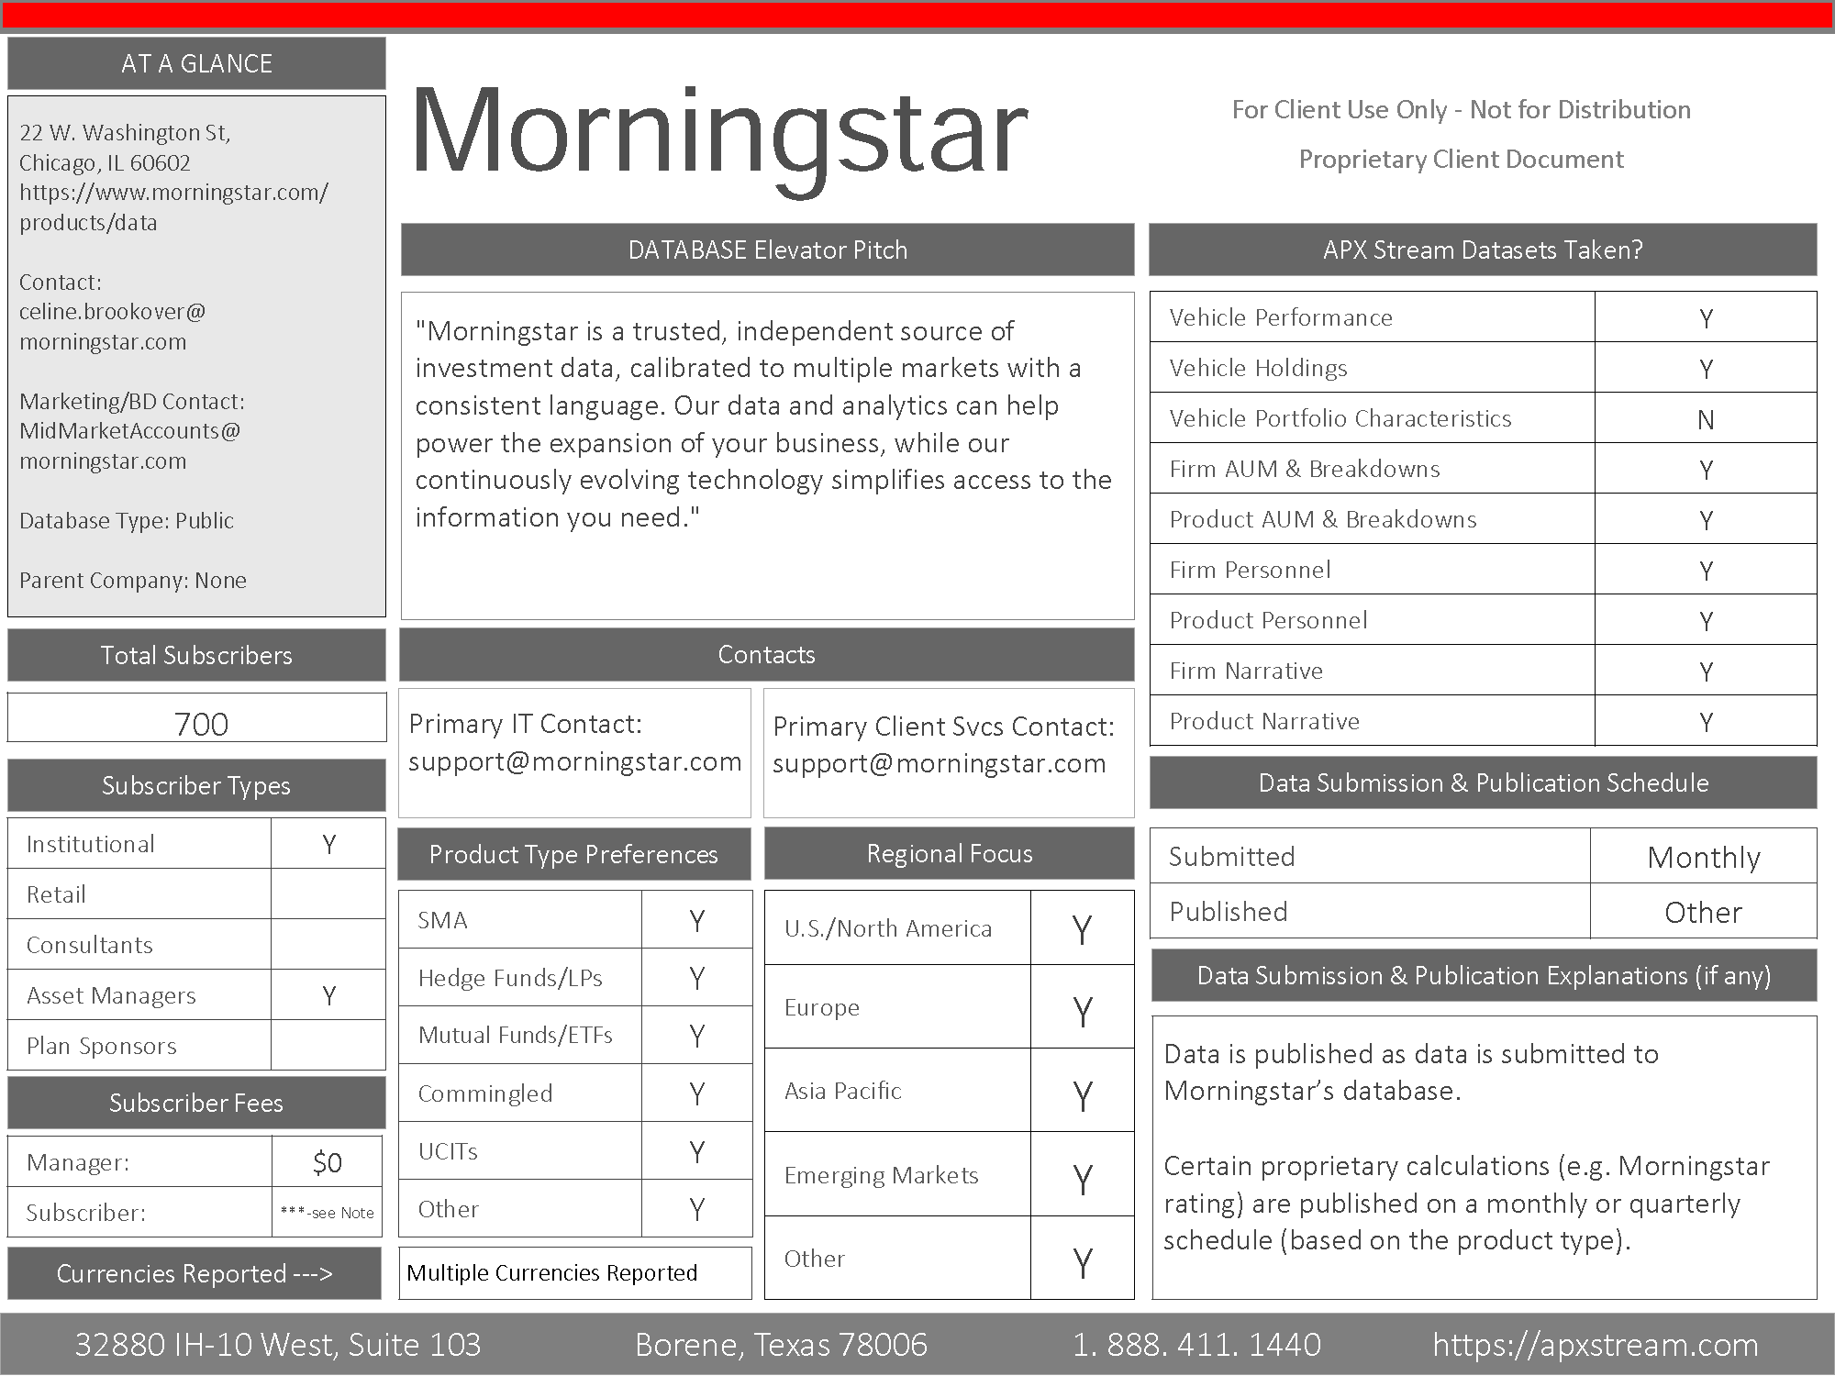

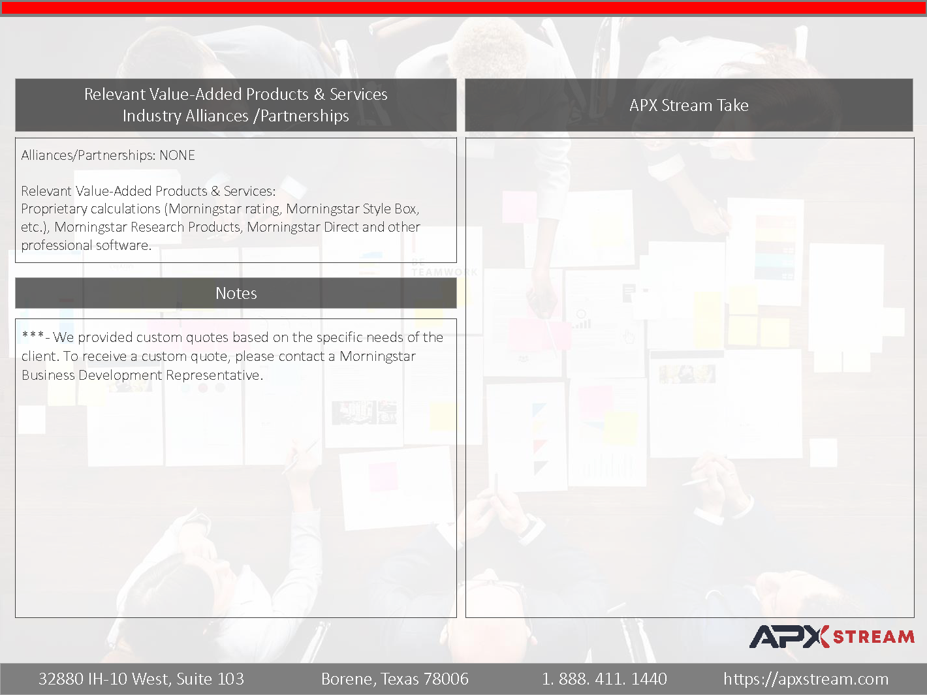**Exhibit 2 – Sample Agreement**

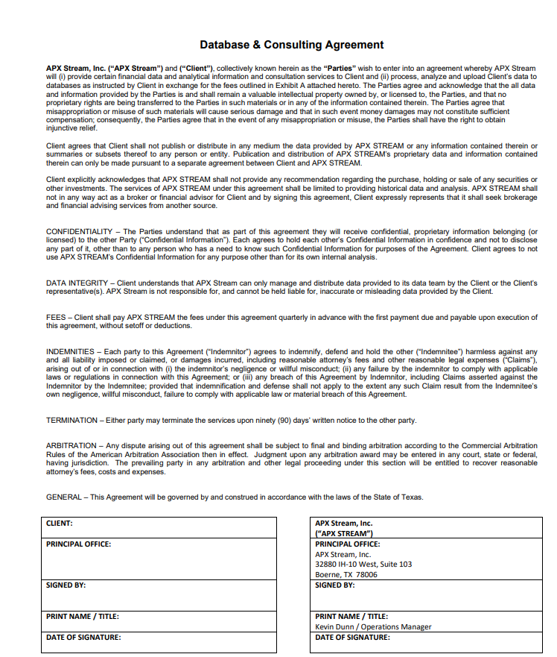**Exhibit 3 Price List**

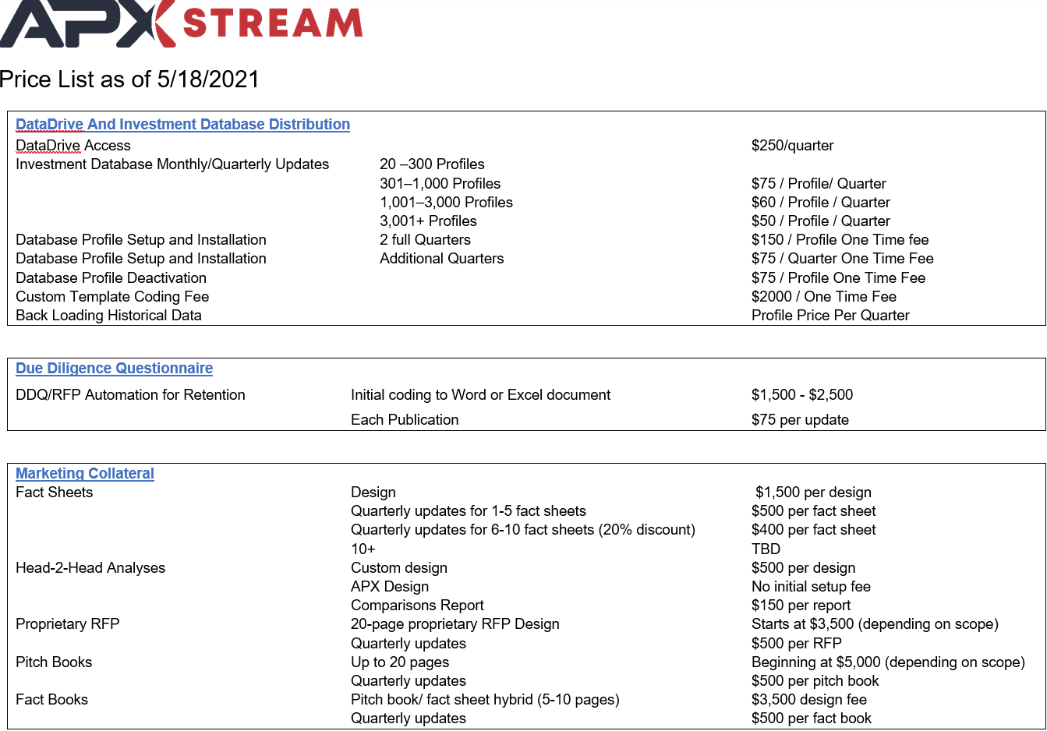

**Exhibit 4 – Master Services Agreement**

